Final Year Project Status Report:

Modelling Transmission line suitable for THz frequencies

Name: Mohammed Al Shuaili

Date: 13/01/2025

Table of contents:

Content page

Introduction and project description ………………………………………………. 3

Critical Review of Background Theory ………………………………………….... 4

Proposed Solutions…………………………………………..................................... 5

Challenges and Mitigation…………………………………………………………. 11

Project Plan for Semester 2 …………………………………………………………12

References ..………………………………………………………………………... 13

Appendix …………………………………………………………………………... 14

**Project Problem Description**

The development of efficient models for terahertz (THz) transmission lines is a critical challenge in modern telecommunications. THz frequencies, which range from 0.1 to 10 THz, offer exceptional bandwidth for applications such as high-speed wireless communication, imaging systems, and advanced sensing technologies. However, designing accurate and computationally efficient models for such systems is difficult due to the unique electromagnetic propagation characteristics at these frequencies, including high attenuation, significant dispersion, and nonlinearities.

A key problem lies in balancing computational efficiency and accuracy in modelling transmission line behaviour. Traditional methods, such as the finite-difference time-domain (FDTD) approach, often require significant computational resources and may not provide the desired level of precision in the time domain. Numerical methods like the Numerical Inverse Laplace Transform (NILT) and RLC ladder approximations offer alternative approaches but come with their own limitations, such as sensitivity to input parameters and numerical stability issues.

**Project Introduction**

**Area and Scope**

This project focuses on the numerical modelling of THz transmission lines using advanced computational methods. The scope includes implementing and validating models such as NILT and RLC ladder approximations to simulate time-domain behaviour accurately.

**Motivation**

The motivation for this work stems from the growing demand for high-speed communication systems operating at THz frequencies. These systems are vital for 6G networks, wireless data centres, and emerging applications like biomedical imaging. Accurate transmission line models are essential to enable the design and analysis of efficient systems for these cases.

**Aim and Objectives**

* **Aim:** Develop and validate numerical models for THz transmission lines suitable for time-domain simulations.
* **Objectives:**
  + Use FDTD methods to create an initial approximation of the transmission line behaviour.
  + Understand and implement NILT to solve exact solutions in the s-domain.
  + Model the transmission line using RLC ladder approximations, convert them to impedances in the s-domain, and use NILT to compare these solutions with the exact solution to determine the number of sections required for accuracy without adding unnecessary complexity.
  + Derive a time-domain equivalent to simulate the RLC ladder and ultimately the transmission line.
  + Extend the models to simulate transmission line behaviour at various frequencies in the THz range.

**Critical Review of Background Theory and Literature:**

**Review of THz Transmission Lines**

Terahertz (THz) transmission lines play a crucial role in high-speed communication, imaging, and sensing systems. However, accurately modelling their behaviour presents challenges due to unique propagation characteristics, such as high attenuation and dispersion. A fractional-order RLGC model for CMOS-based THz circuits, introduced by Shang et al. [4], incorporates causality and frequency-dependent losses, enabling precise analysis of THz transmission lines. Advanced designs, including cyclic olefin copolymer (COC)-based transmission lines, have also been proposed to minimize losses and enhance performance [1].

Recent advancements in terahertz transmission line modelling, such as those proposed in [10], utilize time-domain techniques such as terahertz time-domain spectroscopy (THz-TDS) for material characterization. These methods underscore the importance of precise transmission line models for analysing material properties at terahertz frequencies, closely aligning with the objectives of this project.

**Review of FDTD and RLC Ladder Approximations:**

The finite-difference time-domain (FDTD) method is a widely known numerical technique for modelling transmission lines. Veerlavenkaiah and Raghavan [2] demonstrated how FDTD can calculate propagation constants effectively using MATLAB, offering a rigorous approach to simulating electromagnetic wave behaviour. Montoya [3] extended the use of FDTD to model transmission lines terminated with RLC loads, demonstrating its flexibility in handling practical termination scenarios. Brancik [7] explored time-domain simulations of multiconductor transmission line systems, emphasising the importance of accurate numerical methods for voltage and current wave propagation. While FDTD is robust and accurate, it is computationally demanding for large-scale or high-frequency systems.

The RLC ladder approximation provides a computationally efficient alternative by discretizing the transmission line into sections represented by lumped elements. However, this method can suffer from reduced accuracy at higher frequencies when insufficient sections are used.

**Review of NILT for Time-Domain Analysis**

The Numerical Inverse Laplace Transform (NILT) offers a reliable means to approximate time-domain solutions from s-domain representations. Gad et al. [6] introduced an interpolation-supported NILT method that achieves fast and stable circuit simulations, making it a practical tool for analysing THz transmission lines. This project applies NILT to validate time-domain solutions obtained from FDTD and RLC ladder models. The versatility of NILT in MATLAB-based engineering simulations has been highlighted in prior work by Perutka [8], demonstrating its relevance for applications in electrical engineering and control systems.

**Comparison and Challenges**

Each reviewed method has distinct advantages and limitations. FDTD provides high accuracy but is resource-intensive, especially for long transmission lines or THz frequencies. RLC ladder approximations offer computational efficiency but require careful calibration to balance accuracy and complexity. NILT serves as a valuable tool for transforming exact s-domain solutions into the time domain, enabling validation of results from other methods. Challenges include ensuring numerical stability in NILT and optimizing the number of sections in RLC ladder models for THz applications.

**Proposed Solutions**

**How the Problem Will Be Addressed**The project proposes a step-by-step approach to model and simulate THz transmission lines:

1. **FDTD Approximation:**
   * Use the FDTD method to model the transmission line and obtain an initial time-domain approximation. This step will help understand the general behaviour of the system and validate subsequent methods.

The governing equations for a transmission line using FDTD are derived from the Telegrapher’s equations:

(2)

(1)

Where L and Care the per-unit-length inductance and capacitance, respectively​. As proposed in [5], the transmission line is divided into N sections of length (Δx). Voltages (​) are calculated at the ends of each section, while currents (​​) are computed at the middle of each section as illustrated in Figure 1. Then, ​ and ​​​ can be derived as.

(3)

(4)

Figure : Staggered grid for FDTD method showing spatial (z) and temporal (t) discretization, with voltage (V) at grid points and current (I) at midpoints [5].

Using MATLAB, a lossless transmission line was simulated with the parameters provided in Appendix 1. The results, shown in Figure 2, display the voltage at the load over time. These results will serve as a baseline for validating other methods, such as NILT and RLC ladder approximations. The simulation effectively captures the transient and steady-state behaviour of the transmission line.

Figure : FDTD simulation of the transmission line showing the voltage at the load over time, illustrating the transient response followed by steady-state oscillations.

1. **RLC Ladder Approximation:**

* Model the transmission line using an RLC ladder network, convert its components to impedances in the s-domain, and solve using NILT. Compare the results to the exact solution to determine the number of sections needed for accuracy while keeping the model computationally efficient.

The transmission line is divided into sections, as shown in the Figure 3. Each section consists of lumped resistive (R), inductive (L), and capacitive (C) elements. Voltages (​) are calculated at the ends of each section, while currents (​) are calculated for each section.

Figure : RLC ladder network representation of the transmission line divided into (N) sections, with lumped elements (R), (L), and (C), used to approximate the line's behavior.

**Governing Equations**  
From the RLC ladder network representation, the following equations describe the behaviour of the first section (n=1):

(6)

(5)

where dz is the length of each section, defined as:

where l is the total length of the transmission line, and N is the number of sections. By rearranging and simplifying these equations, we derive:

(8)

(7)

For the general n-th section, the equations become:

(10)

(9)

This process is repeated iteratively for all N sections, resulting in a full system of differential equations describing the voltage and current distributions along the transmission line. Then MATLAB was used to solve them using ode45 solver and obtain the results in Figure 4.

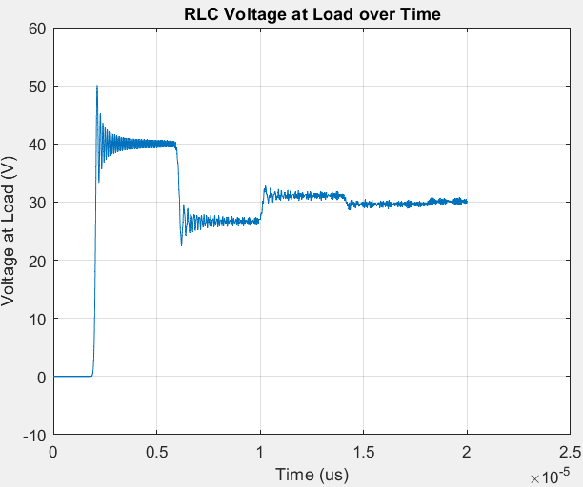

Figure : Simulation of the RLC ladder network showing the voltage at the load over time, illustrating the transient and steady-state responses.

1. Understanding and Implementing NILT**:**
   * The NILT approach can be used to solve the exact solution of the transmission line in the s-domain. Then compare it to the RLC approximation to make it more accurate.

The exact solution for the open-circuit voltage of the transmission line can be derived based on Figure 5:

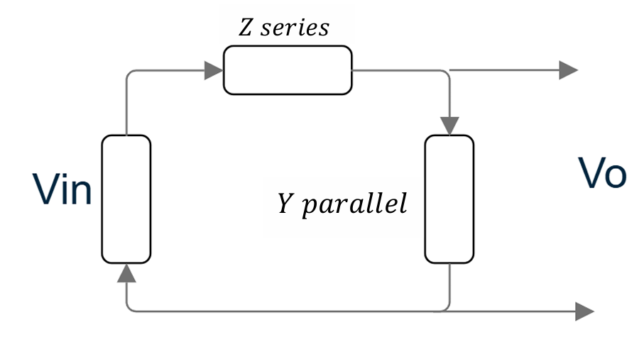

Figure : Equivalent circuit representation of a transmission line segment with series impedance (Z{series}) and parallel admittance (Y_{parallel}) for voltage input (V_{in}) and output (Vo).

Where,

(11))

Using NILTv, this equation can be simulated and solved in the s-domain as described in [7]. The following results were obtained with R = 0- and 30-volts unit input.

Figure : Voltage at the load obtained using NILTv to solve the exact solution, illustrating the periodic behavior due to wave reflection in an open-circuit transmission line.

The Figure shows the open-circuit voltage with a 30 V input, where the wave travels forward and reflects backward, forming a standing wave due to the open termination. This exact solution can also be obtained by representing the RLC Ladder approximation in the state space representation and solving it as outlined in [7].

1. **Deriving a Time-Domain Equivalent for modelling:**

* From the validated RLC ladder approximation, a time-domain equivalent model can be derived to simulate the transmission line directly. This is achieved by systematically comparing the exact solution of the transmission line with the RLC ladder approximation using the same parameters, such as resistance (R), inductance (L), capacitance (C), and the total line length (l). The goal is to determine the minimum number of sections (N) required for the RLC ladder approximation to closely match the exact solution.
* The Figure compares the exact solution (blue) and the RLC ladder approximation (red) for different section counts (N). As N increases, the RLC approximation converges to the exact solution. At lower N, differences are obvious, but by N= 100, the RLC ladder closely matches the exact solution, highlighting the need for sufficient segmentation for accuracy.

Figure : Comparison of RLC ladder approximation (red) and exact solution (blue) for various section N.

Next, by converting the components of the RLC ladder to the s-domain for N=20 to N=40 and using Asymptotic Waveform Evaluation (AWE) [9], a time-domain model can be derived. The s-domain impedances are expressed as:

AWE simplifies the high-order transfer function by matching dominant poles and residues, enabling efficient conversion to the time domain.

This time-domain model can then be tested across different frequency ranges to validate its accuracy and behaviour, ensuring that it’s suitable for THz transmission line simulations.

**Challenges and Mitigation:**

* A major challenge is deriving a time-domain model that accurately matches the exact solution from the s-domain, ensuring it captures both transient and steady-state behaviours across different frequencies. Achieving this requires optimising the number of sections (N) in the RLC ladder while maintaining computational efficiency.
* Another challenge lies in validating the derived model across a wide frequency range to ensure accuracy and efficiency. To address this, iterative testing and comparison with the exact solution, along with error analysis, will be used to refine the model and ensure its reliability for THz applications.

**Project Plan for Semester 2**

Week 1: Review and Validation

This phase will focus on reviewing the current RLC ladder approximation, exact solution, and NILT implementation. Any gaps or inconsistencies will be identified and addressed to establish a solid foundation. Research will also include exploring alternative time-domain approximation methods from different resources.

Week 2-3: S-Domain Modelling and Comparison

The RLC ladder components will be converted to the s-domain for N = 20 and N = 40, and their results compared with the exact solution. Asymptotic Waveform Evaluation (AWE) will be implemented to simplify the transfer function and facilitate time-domain derivation.

Week 4: Time-Domain Derivation

Using NILT, partial fraction decomposition, and insights from alternative approaches, time-domain models will be derived and tested. These models will be analysed for accuracy and compared with the exact solution to ensure they replicate both transient and steady-state behaviours.

Week 7: Frequency Range Testing

The derived time-domain models will be validated across a range of frequencies, including THz, with the exact solution in MATLAB. This comparison will assess the models’ ability to accurately replicate the behaviour of the model under different frequency conditions.

Week 8: Exploratory PSPICE Simulation

PSPICE will be used to explore the feasibility of implementing the derived time-domain model. Initial simulations will assess whether the behaviour of the transmission line can be accurately replicated.

Week 9: Final Validation and Comparison

Final validation of the models will be conducted against benchmarks or experimental data with reference to the results found in [5]. Performance comparisons with other modelling approaches, such as FDTD, will focus on accuracy and efficiency.

Week 10: Finalization and Reporting

The project will conclude with the finalization of the validated model and the preparation of a detailed report. This report will summarize the methodology, results, and comparisons, providing insights and recommendations for future work.

**References:**

1. A. Chahadih *et al*., "Low loss microstrip transmission-lines using cyclic olefin copolymer COC-substrate for sub-THz and THz applications," *2013 38th International Conference on Infrared, Millimeter, and Terahertz Waves (IRMMW-THz)*, Mainz, Germany, 2013, pp. 1-2, doi: 10.1109/IRMMW-THz.2013.6665702.
2. D. Veerlavenkaiah and S. Raghavan, "Determination of propagation constant using 1D-FDTD with MATLAB," *2016 International Conference on Communication Systems and Networks (ComNet)*, Thiruvananthapuram, India, 2016, pp. 61-64, doi: 10.1109/CSN.2016.7823987.
3. T. P. Montoya, "Modeling 1-D FDTD transmission line voltage sources and terminations with parallel and series RLC loads," *IEEE Antennas and Propagation Society International Symposium (IEEE Cat. No.02CH37313)*, San Antonio, TX, USA, 2002, pp. 242-245 vol.4, doi: 10.1109/APS.2002.1016969.
4. Y. Shang, H. Yu and W. Fei, "Design and Analysis of CMOS-Based Terahertz Integrated Circuits by Causal Fractional-Order RLGC Transmission Line Model," in *IEEE Journal on Emerging and Selected Topics in Circuits and Systems*, vol. 3, no. 3, pp. 355-366, Sept. 2013, doi: 10.1109/JETCAS.2013.2268948.
5. C. R. Paul, "Incorporation of terminal constraints in the FDTD analysis of transmission lines," in *IEEE Transactions on Electromagnetic Compatibility*, vol. 36, no. 2, pp. 85-91, May 1994, doi: 10.1109/15.293284.
6. E. Gad, Y. Tao and M. Nakhla, "Fast and Stable Circuit Simulation via Interpolation- Supported Numerical Inversion of the Laplace Transform," in *IEEE Transactions on Components, Packaging and Manufacturing Technology*, vol. 12, no. 1, pp. 121-130, Jan. 2022, doi: 10.1109/TCPMT.2021.3122840.
7. L. Brancik, "Matlab based time-domain simulation of multiconductor transmission line systems," *The IEEE Region 8 EUROCON 2003. Computer as a Tool.*, Ljubljana, Slovenia, 2003, pp. 464-468 vol.1, doi: 10.1109/EURCON.2003.1248066.
8. K. Perutka, Ed., *MATLAB for Engineers: Applications in Control, Electrical Engineering, IT and Robotics*. Rijeka, Croatia: InTech, 2011. Available: <https://doi.org/10.5772/2468>.
9. W. T. Smith and S. K. Das, "Application of asymptotic waveform evaluation for EMC analysis of electrical interconnects," *Proceedings of International Symposium on Electromagnetic Compatibility*, Atlanta, GA, USA, 1995, pp. 429-434, doi: 10.1109/ISEMC.1995.523595.
10. F. Vandrevala, "Transmission Line Model for Material Characterization using Terahertz Time-Domain Spectroscopy," Ph.D. dissertation, Univ. of Virginia, July 2019.

**Appendix**

1. **FDTD Matlab Code:**

1. clear all

2. clc

3. % a lossless , two-conductor line with Vs(t)=30,

4. % Rs = 0 R, VL(t) = 0, and RL = 100 R. The line is of

5. % length L = 400 m and has TJ = 2 x 10' m/s and ZC = 50 R

6. %%%%%%%%%%%%%%%%%%%%%%%%%%%%%%%%%%%%%%%%%%%%%%%%%%%%%%%%%%%%%%%%

7.

8. L_total = 400; % Total length of the line (m)

9. Zc = 50; % Characteristic impedance (Ohms)

10. v = 2e8; % Speed of propagation (m/s)

11. Rs = 0; % Source resistance (Ohms)

12. RL = 100; % Load resistance (Ohms)

13. Vs = 30;% % Input voltage (V)

14. % Compute inductance and capacitance

15. C = 1 / (v * Zc);

16. L = Zc/v;

17. NDZ = 200; % Number of spatial steps

18. dz = L_total / NDZ; % Spatial step delta z

19. dt = 1e-11; % Time step delta t

20. t_max = 20e-6; % Maximum simulation time (20 as in the paper)

21. t_steps = round(t_max / dt); % Number of time steps

22. % allocate voltage and current arrays

23. V = zeros(NDZ+1, t_steps);

24. V(1,:)=Vs*ones(1,t_steps);

25. I = zeros(NDZ, t_steps);

26. % FDTD Loop for Time Stepping

27. for n = 1:t_steps-1

28. V(1,n+1) = V(1,n);

29. for k = 1:NDZ

30. if k>1

31. V(k,n+1) = V(k,n) + dt/(dz *C)* (I(k-1,n) - I(k,n)); % Update voltag

32. dV_k = V(k-1,n) - V(k,n); % Voltage difference between points

33. I(k-1,n+1) = I(k-1,n) + dt/(dz *L) * dV_k;

34. end

35. end

36. V(NDZ,n+1) =V(NDZ,n)+dt*(I(NDZ-1,n)/(C*dz)-V(NDZ,n)/(RL*C*dz));

37. end

38.

39. % Plot the results for the voltage at the load

40. figure(1)

41. plot((0:t_steps-1)*dt/1e-6, V(NDZ,:));

42. xlabel('Time (\mus)');

43. ylabel('V Load (Volts)');

44. title('FDTD Simulation of Transmission Line');

45. grid on;

46.

**2. RLC Ladder code :**

1. function df = fline(t, y,N,L,C,R,Rs,Rl,Vs)

2. % coudn't find a use for t maybe if the source is a sin or cos

3. df = zeros(2 * N, 1);

4. % Currents and voltages

5. In = y(1:2:2*N); % Currents

6. Vn = y(2:2:2*N); % Voltages

7. % Boundary conditions at the source end (n=1)

8. df(1) = (-1 / L) * Vn(1) - (Rs + R) / L * In(1) + (1 / L) * Vs; % dI1/dt

9. df(2) = (1 / C) * In(1) - (1 / C) * In(2); % dV1/dt

10. % Interior sections (n=2 to N-1)

11. for n = 1:N-1

12. df(2*n + 1) = (-1 / L) * Vn(n+1) - R / L * In(n)+(1 / L) * Vn(n); % dIn/dt

13. df(2*n) = (1 / C) * In(n) - (1 / C) * In(n+1); % dVn/dt

14. end

15. %df(2*N-1) = 0; % no inducatnce so =0

16. df(2*N-1) = (-1 / L) * Vn(N) - R / L * In(N) + (1 / L) * Vn(N-1);

17. df(2*N) = (1 / C) * In(N) - Vn(N) / (Rl * C); % dVN/dt (voltage at the load)

18. end

19.

1. clear all

2. clc

3. len=400;

4. N = 10; % Number of sections in the transmission line

5. dz=len/N;

6. L = 2.5e-7*dz; % Inductance

7. C = 1e-10*dz; % Capacitance

8. R = 0; % Resistance per section

9. Rs = 0; % Source resistance

10. Rl = 100; % Load resistance

11. Vs = 30; % Source voltage (could be a function of time)

12. y0 = zeros(2 * N, 1);

13. tspan = [0 20e-6];

14. % Solve using ode45

15. [t, y] = ode45(@(t, y) fline(t, y, N, L, C, R, Rs, Rl, Vs), tspan, y0);

16. % Plot voltage at the end of the transmission line (VN)

17. figure(1);

18. plot(t, y(:,N*2)); % Plot voltage at the load (VN)

19. xlabel('Time (us)');

20. ylabel('Voltage at Load (V)');

21. title('Voltage at Load over Time');

22. grid on

23. %xlim([0 tspan(2)]);

24.